**Study of the relationship between drought index and Groundwater recharge, case of an aquifer in a semi-arid area**

Ali Rahmani Salah Eddine 1, Chibane Brahim 1, Hallouz Faiza 2 ,Boucefiene Abdelkader2

Author contact: [alirahmani101990@gmail.com](mailto:alirahmani101990@gmail.com)

Phone + 213 0669606978

1 Geo-environment Laboratory FSTGAT, University of Sciences and technology Houari Boumediene , BP 32 EL ALIA 16111 BAB EZZOUAR ALGIERS, Algeria

2 University of Khemis Miliana, Algeria

2 Earth science department, University of Djilali Bounaama Khemis-Miliana, Algeria

**Abstract**

As a result of climate change, the ground water recharge was influenced by the moderate rainfall, to understand the relationship between the Drought index and the GWR; we simulate the response of aquifer to the change in the climate condition by using the groundwater recharge estimated by a recent model developed by B.chibane et al; and the Standardized Precipitation Index (SPI).

The area of study was located from 300 Km south of Algiers (Algeria), it was characterized by a semi-arid climate and a moderate rainfall (between 200 and 350 mm) and it was characterized by an average annual temperature around (15 °C).

This study let us to adjust a general model , show clearly the relation between drought and the groundwater recharge , to give us a general idea to understand the phenomenon of the aquifer recharge in semi arid area , also give to the administrator a real tools to understand and to manage sustainably the groundwater resources; under climate change scenarios

**Key words:** Climate change, Drought index, SPI, Groundwater recharge, semiarid area

1. **Introduction**

Drought is the most known natural disaster in the entire world, it can be defined as a natural phenomena resulting from a lack of water resources in two cases: Period of below normal precipitation (Meteorological Drought) or period of below average runoff (Hydrologic Drought). This is due to the continuing decline in precipitations in term of time and space. Decreases of rainfall will decrease all the hydrological terms units (Runoff, Groundwater recharge and soil moisture).Drought is depending on lot of conditions: degree of Temperature, Rainfall amount, and the atmospheric conditions (Pressure, wind, and humidity of air).

Drought has lot of affect on economic and social plan (Agricultural activities, and population water supply program).

The standardized Precipitation index (SPI) is a very general parameter the mostly used to control drought in different time and space scales. The SPI let us to understand the effects of climate change (McKee et all, 1995); and let us also to predict some variation in the hydrologic regime in the area of study (S.Pashiardis et al, 2008); This index was developed and proposed by McKee et all in 1993 (M.Svoboda, 2009).By Understanding the relationship between the different studied terms we can establish an efficiency model to manage better our groundwater resources. Many changes in hydro-climatic regime are observed at the long time-scale.

Groundwater recharge present a complicated variable to the administrator, Many difficult were founded in the ground, make the estimation of groundwater reserve a very complicate operation (W.Kinzelbach et al, 2002), we try in this work to find a relationship between groundwater reserve and the hydro-climatic index.

1. **Materials and methods**

The idea of this simple work aim to find a relationship between the drought index and the influence of it variation on groundwater recharge, this is down by calculating the SPI index and the GWR for a long period of time. We look to find the best fit model.

This study let us to characterize the climatic regime of the area of study; and its impact on the sustainability of the groundwater recharge vs. climate change.

**II.1.Characteristic of Area of study:**

The Basin of Oued-Djelfa (Fig.1) was located at 300 Km South of Algiers (Algeria); it was characterized by a moderate climatic regime. With an annual rainfall between (200-350 mm) and an average annual temperature about 15°C.with and area of 1300 km².

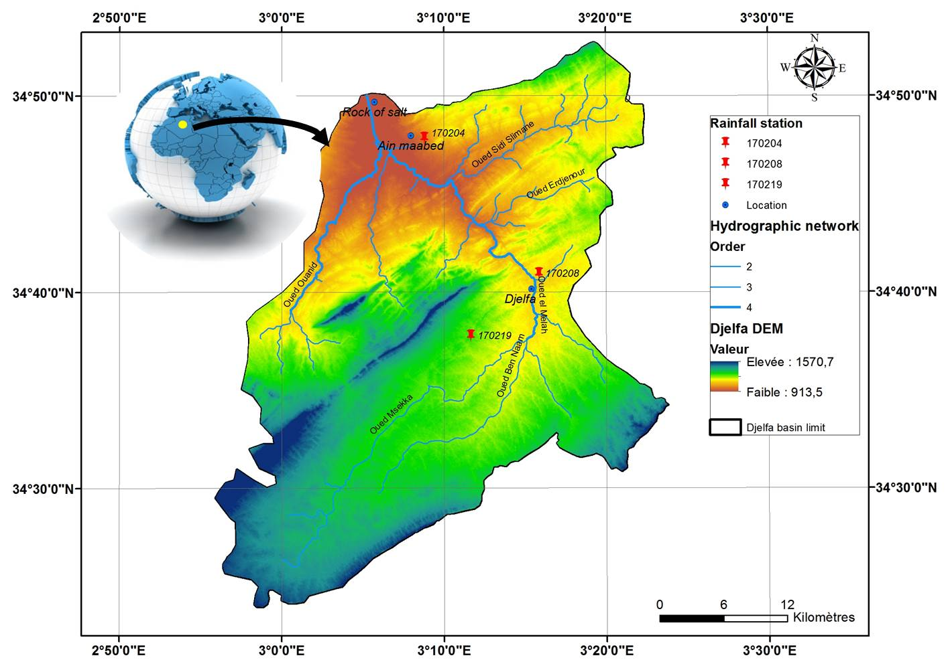

Fig.1 Study Area

1. **Groundwater recharge estimation**

Estimation of Groundwater recharge is a very complicated process; in this research The GWR was estimated by using a new hydrologic model developed by (Chibane et al, 2015). The general model proposed was given by the following equation:

${GWR}_{m}=0.135×\left(\frac{φ}{α}\right)×e^{0.01047×P}$ (1)

With GWRm: Natural groundwater recharge given in mm; P: annual average rainfall, α and β temperature coefficient dependent

Where

$α=\frac{T^{2}+1}{T(T-12)}$ (2) and $φ=\frac{\sqrt{T^{2}-1}}{T}$ (3)

1. **Runoff estimation**

Surface runoff is depend on lot of parameter (Rain intensity , Soil characteristic , slope and basin characteristic) The estimation of runoff in the area of study was estimated using formula derived from the model of Tixeront-Berkalof modified by Romantchok 1971. This formula was proposed in recent work of Chibane et al.

The formula of Runoff is given by the following equation:

$Runoff={\left(0.01.P\right)}^{2.4}$ (4)

Runoff: surface runoff given in mm P: annual average rainfall given in mm

1. **Drought Index**

In this work we have used two index; the first is the Standardized precipitation index abbreviated (SPI) , the second called Standardized runoff index abbreviated (SRI) , this index is used to study the effect of climate variability on Groundwater recharge, the two index was calculated using the following equations (eq.5) in below (B.Fuchs,2012), SPI drought index classes were given in Table-I.

$SPI=\frac{Pi-P_{m}}{δ}$ (5)

With: Pi: precipitation corresponds to I year; Pm mean precipitation of the study time series δ: the standard deviation of the precipitation study series.

Table I. standardized Precipitation index Classification

|  |  |  |
| --- | --- | --- |
| Spi values | classifications | abbreviation |
| 2.00 and more  1.50 to 1.99  1.00 to 1.49  0.99 to 0.00  0.00 to -0.99  -1.00 to -1.49  -1.50 to - 1.99  -2.0 and less | Extremely wet  Very wet  Moderately wet  Normal  Near normal  Moderately drought  Severe drought  Extremely drought | EX  VW  MW  N  NN  MD  SD  ED |

The SPI describe the drought due to precipitation, increasing rainfall, will increase the rate of infiltration, Runoff, in the opposite side, decreasing of the amount of precipitation, will decrease the groundwater recharge, and the surface runoff.

in Fig.2 and Fig.3 a regression model are given for groundwater recharge in function of rainfall, and runoff vs. precipitation.

Fig.2: Groundwater recharge variation in function of annual rainfall, this curve was established using a model developed by (Chibane ET all, 2015).

Fig.3: Runoff variation in function of annual rainfall, this curve was established using a model developed by (Chibane ET all, 2015).

Analysis of this two regression plot show a best regression model fit for the two studied parameter (GWR and Runoff) in function of the basic input parameter in our study cases (Precipitation).

1. **Results and discussion**

Visual representation of results analysis of Drought index vs. Rainfall, Temperature, Runoff, SPI index, and GWR rate values let us to give the variation level of this parameters in 2D contour plots. Firstly the contour plot of SPI vs. (Rainfall and Temperature), as we show in the contour map in (Fig.4) the SPI value was classed in different group each class describe the drought or wet climate situations ; which varies from equal or less than (-2) to equal or more than (+2) .

SPI calculated for the region of Djelfa, it correspond to the average annual precipitation for a series of 34 year, it located between the contour interval [-1 to 0] which correspond to moderate drought class to near normal.

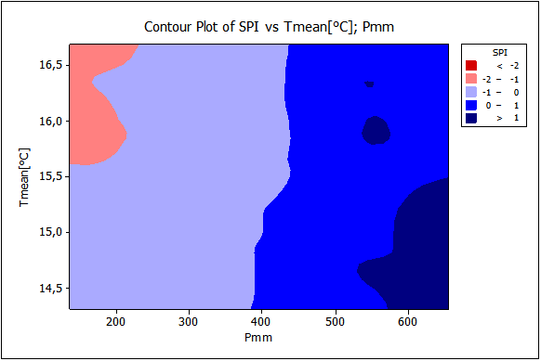

Fig.4 Contour plot of SPI vs. Average annual rainfall and Temperature

Secondly The variation of GWR vs. SPI let us to establish a regression best fit model who gives the value of GWR in function of SPI. The regression plot was showed in the Fig.5

Fig.5: variation of GWR vs. SPI

The equation of fit model was given as follow:

$$GWR=1.9733×e^{1.3054×SPI}$$

The 2D contour plots give the variations of GWR vs. SPI and temperature are illustrate in Fig.6; it appear clearly that the GWR are less than 5 mm for the drought index correspond to the SPI class from -2 to +0.99 which correspond to the severe drought (SD) and Normal (N) SPI index classes. The information extracted from this plot confirms that the GWR are low in the period of Drought.

We see also that the groundwater recharge are medium (between 5 and 10 mm /year) when SPI values are situated between [+1 to +1.4] those correspond to moderate Wet class (MW).

The high groundwater recharge (GWR) values (more than 10 mm) are correspond to very wet to extremely wet class (VW and EX) which SPI values are more than or equal (+1.5).

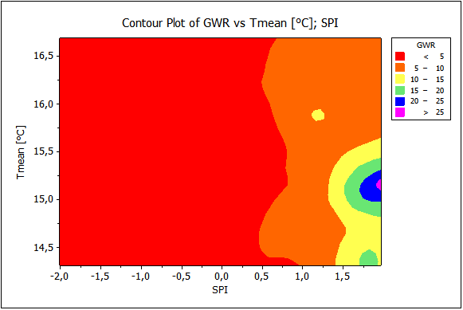

Fig.6 Contour plot of GWR vs. Average annual temperature and SPI

Thirdly the variation of surface runoff vs. SPI let us to trace a regression model who gives the value of runoff in function of SPI. The regression plot was showed in the Fig.7

Fig.7: variation of Runoff vs. SPI

The model describes runoff in function of SPI was given by the next equations:

$$Runoff=24.026×e^{0.8466×SPI}$$

The 2d plot show the variation of Runoff in function of SPI and average annual temperature are given in the Fig.8.

Analysis of the results illustrated in the Fig (7 and 8) show that when the SPI value is less the Zero, the surface runoff in general are less than 40 mm/ year.

The low surface runoff is a results of low precipitation in the annual time scale , increases of air temperature will arise the evapotranspiration , and decrease the surface runoff.

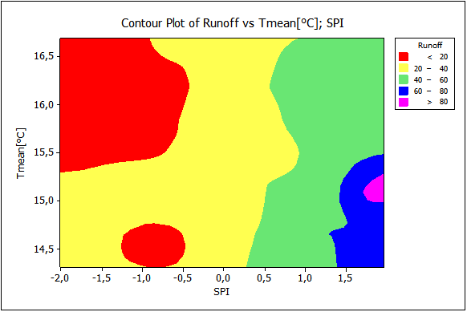

Fig.8 Contour plot of Runoff vs. Average annual temperature and SPI

In general the deficit in precipitation has a great impact on the hydrologic cycle; continuous increases in the amount of rainfall in small and long scale will reduce the infiltration (M.Kimoto et al ,2005), surface runoff, deep percolation. Temperature rises has also an impact on the atmospheric condition, the humidity in air will decrease, and ocean temperature arise. These extreme conditions disturb the air masses circulation in the atmosphere (Xu et al. 2007).

Decreases of deep percolation and soil moisture in the vadose zone will reduce the water amount who can supply the saturated zone.

We have proved by using 2D contours plot the existence of a mathematic relationship between Groundwater recharge, amount of precipitation and Drought index.

Three contour plots was established, the results are presented in the Figure (6,7 and 8), from these maps we see that Groundwater recharge in the medium are less than 10 mm/year which correspond to the moderate drought (MD) to near normal (NN) from SPI class and the normal annual precipitation in the study area ; the average annual rainfall in general are less than 450 mm.

**Conclusion**

At the end of this paper we have arrived to establish a mathematical relationship between Drought index; in this study the Standardized precipitation index (SPI) and two parameters of the hydrological cycle (Groundwater recharge and surface Runoff); three 2D contours plots are established to give a clear visualization of the variations observed at the annual time scales of the GWR and Runoff vs. annual average temperature and SPI. We have proved that the GWR are low (less than 5mm) when the SPI index are less than (+0.99); in the opposite side are high (more than 10 mm) when SPI are more than (+1). The results obtained in this study are in compliance with the characteristics of the semi-arid area, where our study area belongs. We will continue this study in our future research paper, to can manage better the drought phenomena, to can manage better our Groundwater resources by a sustainable management based on different scientific basis.

**References**

### B. CHIBANE, S.E. ALI-RAHMANI, 2015, Hydrological Based Model to Estimate Groundwater Recharge, Real Evapotranspiration and Runoff in Semi-Arid Area, Larhyss journal, N°23 (2015): Issue 23, ISSN: 1112-3680

Brian Fuchs,2012, Using the Standardized Precipitation Index (SPI) and the Standardized Precipitation Evapotranspiration Index (SPEI), National Drought Mitigation Center ,University of Nebraska-Lincoln , Caribbean Drought Workshop May 22-24, 2012.

Kimoto, M., Yasutomi, N., Yokoyama, C. & Emori, S.2005. Projected changes in precipitation characteristics around Japan under the global warming. *SOLA*, 1,doi:10.2151/sola.2005-023.

Mark Svoboda, 2009, Applying the Standardized Precipitation Index as a Drought Indicator National Drought Mitigation Center, University of Nebraska-Lincoln, Mali Drought Monitoring Workshop, Bamako September 14-17, 2009

McKeeT. B.; N. J. Doesken; and J. Kleist. 1995. “Drought monitoring with multiple time scales.” Proceedings of the Ninth Conference on Applied Climatology; American Meteorological Society, Boston, pp. 233–236.

S.Pashiardis, S.Michaelides, 2008, Implementation of the Standardized Precipitation Index (SPI) and Reconnaissance Drought Index (RDI) for Regional Drought Assessment: A case study for Cyprus, European Water 23/24: 57 65, E.W.Publications

W.Kinzelbach, W.Aeschbach, C.Alberich, I.B.Goni, U.Beyerle, P.Brunner, W.H.Chiang, J.Rueedi, and K.Zoellmann, 2002, A Survey of Methods for Groundwater Recharge in Arid and Semi-arid regions. Early Warning and Assessment Report Series, UNEP/DEWA/RS.02-2. United Nations Environment Programme, Nairobi, Kenya, ISBN 92-80702131-3.

Xu, X., Shi, X., Xie, L. & Wang, Y. 2007. Consistency of interdecadal variation in the summer monsoon over eastern China and heterogeneity in springtime surface air temperatures. J. Meteorol. Soc. Japan, 85A, 311–323.